Project Report

|  |  |
| --- | --- |
| Project Title | Problem Manage a Server Outage Scenario & an Issue & Change Request Management System |
| Qualification Name (NICF) | Advanced Certificate in Software Applications (Development and Deployment) |
| Product Name |  |
| Module Name (NICF) |  |

|  |  |  |  |
| --- | --- | --- | --- |
| Student name | | Assessor name | |
| Chathushi Jayarathna | | Ms. Arvinder Kaur | |
| Date issued | Completion date | | Submitted on |
| 10/10/2022 | 27/10/2022 | | 27/10/2022 |
|  | |  | |
| Project title | Student Registration Form Development | | |

|  |
| --- |
| Learner declaration |
| Student signature: **Chathushi**  Date:27/10/2022 |

Table of Contents

1. Project Background 2

2. Project Objectives 3

3. Project Requirements Specifications 6

3.1 Functional Requirements 6

3.2 Non-functional requirements 6

4. Problem Management 7

4.1 Phases of Problem Management 8

i. Problem Identification 8

ii. Problem Control 9

iii. Error Control 9

4.3 Problem Management Examples 11

5. Various tools, process & technologies to facilitate problem identification, investigation, analysis & resolution 13

6. Investigate & Diagnose problems. 15

6.1 Investigate Problem 15

6.2 Diagnose the Problem 15

7. Explain and Prioritize 19

7.1 Prioritize and Categories problems: 19

8. Problem Management Solution 20

9. Systems will be implemented 22

10. Best Practices in Problem Management 29

Figure 1:Screenshot of Eclipse IDE 4

Figure 2:Screenshot of MySQL Workbench 5

Figure 3:Screenshot of Microsoft Word 5

Figure 4:Screenshot of Microsoft PowerPoint 6

Figure 5:Screenshot of Drawio 6

Figure 6:Phases of problem Management 9

Figure 7:Problem Identification - Screenshot of login 12

Figure 8:Problem Identification - Screenshot of Landing Page 13

Figure 9:Screenshot of debugging in eclipse step 1 17

Figure 10:Screenshot of debugging in eclipse step 2 17

Figure 11:Screenshot of debugging in eclipse step 3 18

Figure 12:Screenshot of debugging in eclipse step 4 18

Figure 13:Screenshot of debugging in eclipse step 5 18

Figure 14:Screenshot of debugging in eclipse step 6 19

Figure 15:Screenshot of debugging in eclipse step 7 19

Figure 16:Screenshot of debugging in eclipse step 8 19

Figure 17:Screenshot of debugging in eclipse step 9 20

Figure 18:Problem Priorities and Categories Diagram 21

Figure 19:Screenshot of MainController.java before fixing the problem 22

Figure 20:Screenshot of MainController.java after fixing the error 22

Figure 21:Registration Process - Screenshot of Home Page 24

Figure 22:Registration Process-Screenshot of Registration Page 25

Figure 23:Login Process - Screenshot of User Home Page 26

Figure 24:Login Process-Screenshot of User Login 26

Figure 25:Login Process - Screenshot of User Profile Page 27

Figure 26:Login Process - Screenshot of Admin Login 27

Figure 27:Login Process - Screenshot of Admin Profile Page 28

Figure 28:Search User - Screenshot of User Search User 29

Figure 29:Search User - Screenshot of Admin Search User 29

Figure 30:Update Profile - Screenshot of update profile page 30

Figure 31:Update Profile - Screenshot of User Profile page with Edit Function 30

Project Background

ABC Jobs Pte Ltd is a career guidance organization that gives tasks to individuals. That organization needs to foster a community portal to spread its name to additional clients

ABC Jobs Pte Ltd suggests occupations and recruits laborers. With this community portal, clients can enlist for themselves and quest the most prominent positions in their occupations. Likewise, clients can make networks with other clients by interfacing with them in their local area. Likewise, the gateway is principally utilized for proficient collaborating and vocational development

The primary motivation behind this task is to design and develop the community portal as they wish. Locally community portal clients will actually want to enroll and look for another client. After they can log in, reset their password, and update their profile. User details are stored in a database. This ABC Community portal entryway is very valuable to the client side since clients do not have to go to ABC Jobs organization to look through positions, they can look online with the local area gateway. Likewise, clients should need to safeguard a client profile to acquaint themselves. This people group entryway has private and public modules. Confidential modules approach for the administrators and public modules approach programming software engineers.

For this local community portal, we have carried out a java-based web application with a spring MVC structure for the client necessities, business needs, and cycles. Likewise, we want to design, make, plan and execute the tests for this undertaking. As a component of this task, we really want to recognize this problem and oversee it across its lifecycle

Project Objectives

* Scope of the project
* Explain principles of problem management across its lifecycle.
* Use various tools, process and technologies to facilitate problem identification, investigation, analysis & resolution
* Explain various steps to investigate & diagnose problems.
* Prioritize & Categorize change requests.
* Prepare a solution to address the root cause of the problem.
* Document & monitor the problems
* Explain best practices in documenting problems.
  1. **Tools & Platforms used**
* 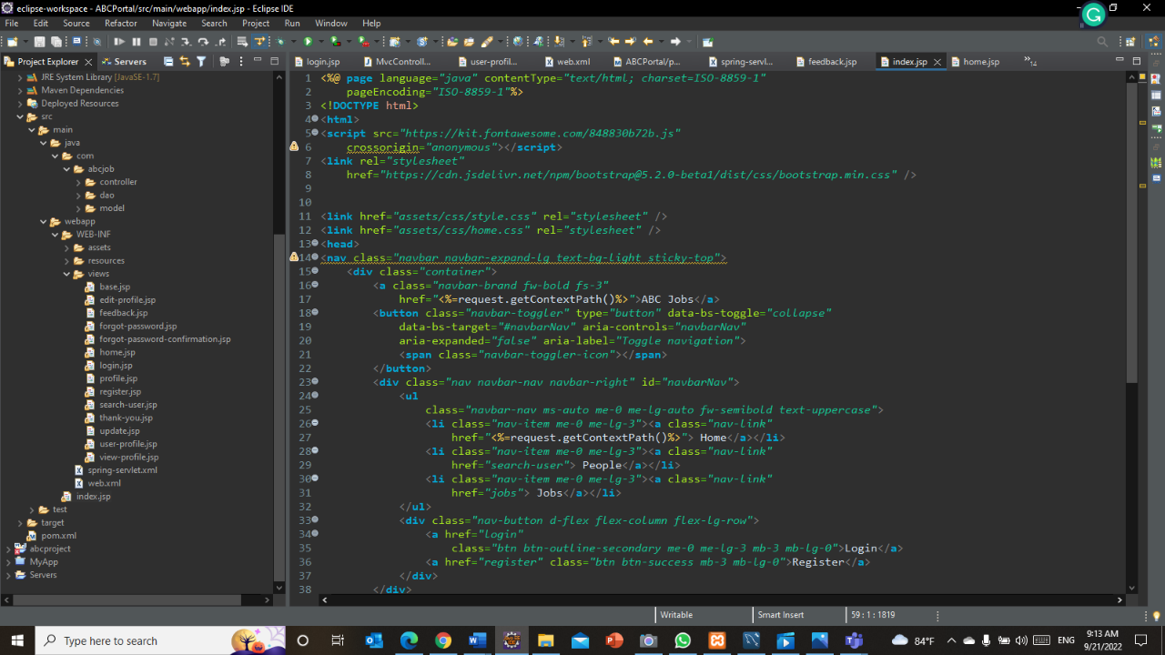Eclipse IDE for Enterprise Java and Web Developers - 2022- 03 – To implement application

Figure :Screenshot of Eclipse IDE

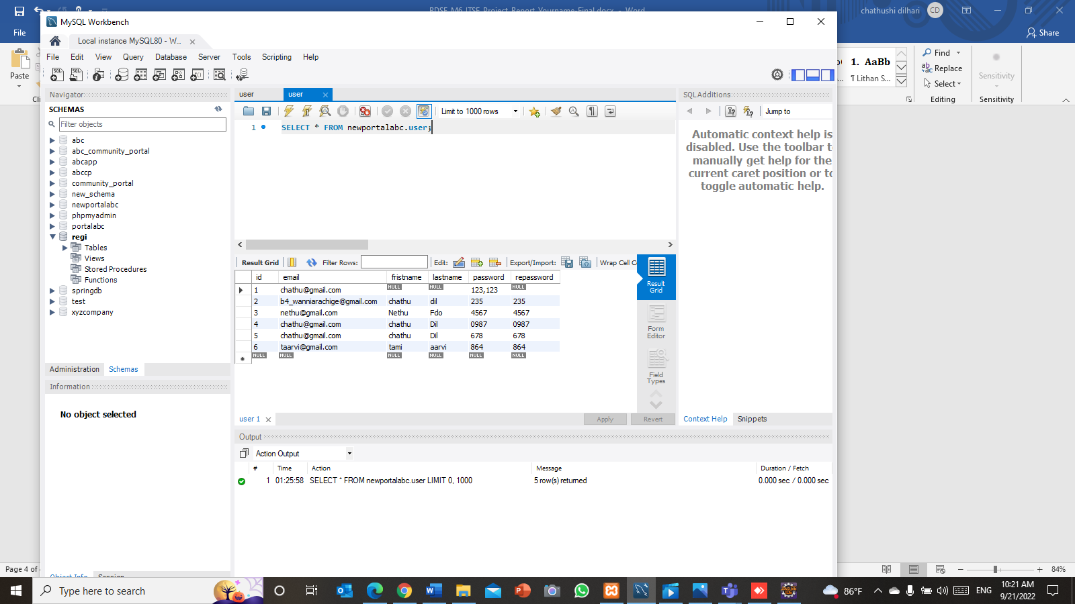MySQL Workbench 8.0 CE – To create ate database

Figure :Screenshot of MySQL Workbench

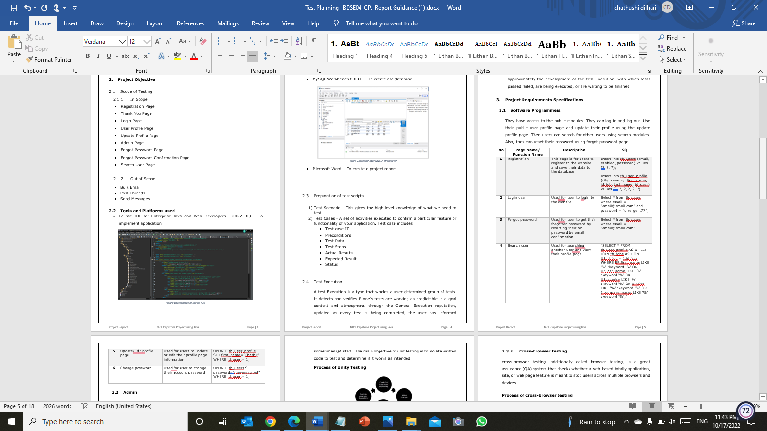Microsoft Word – To create e project report

Figure :Screenshot of Microsoft Word

* Microsoft PowerPoint – To create project presentations

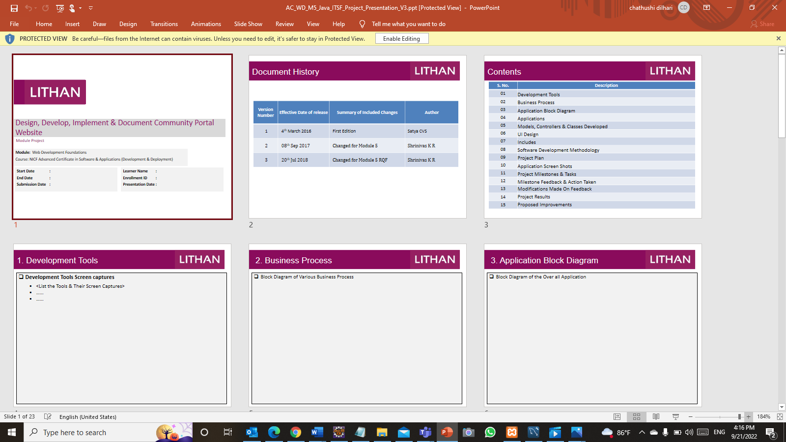

Figure :Screenshot of Microsoft PowerPoint

Diagram.net – To create flow charts, site map

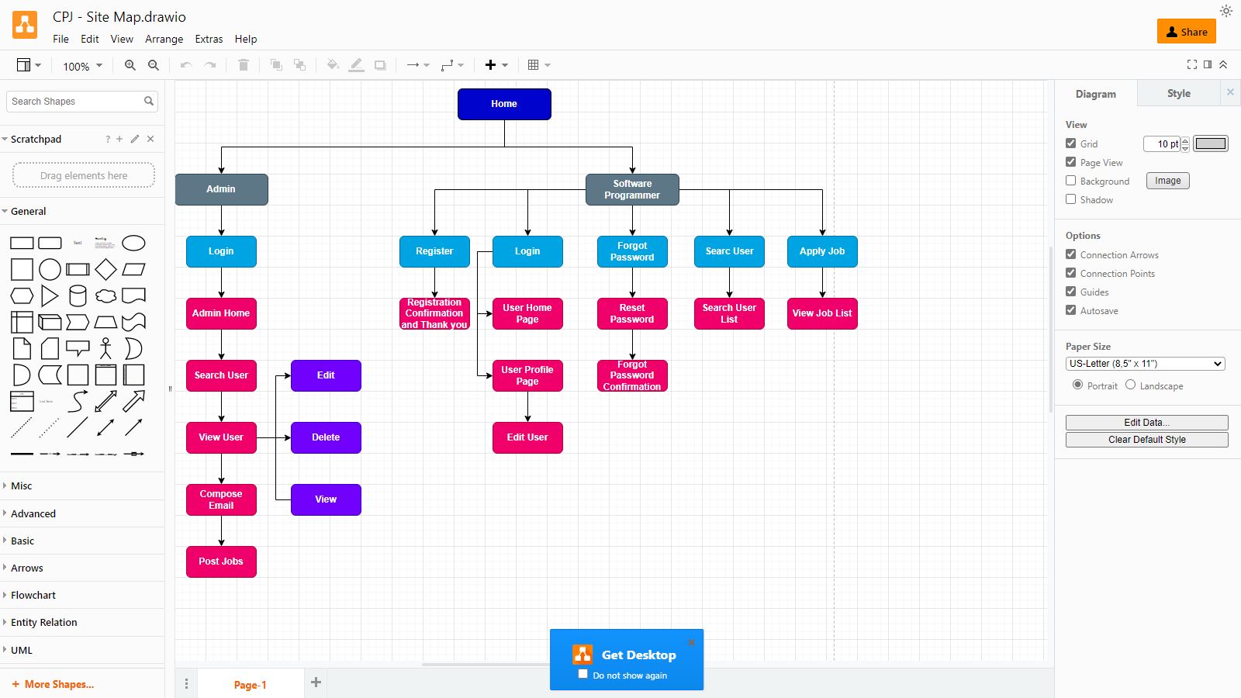

Figure :Screenshot of Drawio

1. Project Requirements Specifications
   1. Functional Requirements

* Users (Software Programmer)
* Registration – This page is for users to register to the website and save their data to the database
* Login - Used a for a user to log into the website
* Forgot Password - users for a user to get their forgotten password by resetting their old password by email confirmation
* Search user - Used for searching for another user and viewing their profile page
* Edit Profile – Used for a user to update or edit their profile page information
* Apply Job - Used for a user to apply to a job that exists on the website
* Administrator
* Login – Used for admin to log in as an administrator of the website
* Dashboard – Administrator page to manage all the users of the website, this page includes add, view list user, edit user, delete user, send bulk email, posting jobs, and accepting users to the job functionality.
* Add user – Used for adding a new users to the application from the admin side
* Edit user – Used for editing user data
* Delete user – Used for deleting user data
* Job posting – Used for posting jobs opportunity to the software programmers/user of the website
* Bulk Mail – Used for sending bulk emails
  1. ****Non-functional requirements****
* Safety requirements

The database has the personal facts of users, due to that it secures with a robust password. also, the passwords of users are encrypted and stored in a database

* Performance attributes
* Availability - The network Portal is operational 24 hours a day
* Correctness - The consequences users are seeking out in a search function much like the results users need t get. additionally, whilst the user logged into the community portal correct user web page is showing
* Maintainability - The community portal is frequently monitored and maintained through the Admin
* Usability - ABC network portal can include a bulky quantity of users and has a huge capacity to stock user records
* Performance Requirements
* Concurrent quantity of customers - 100
* Loading time - 15sec
* Security Requirements

|  |  |  |  |
| --- | --- | --- | --- |
| .permit all() | .hasAnyRole | .hasRole(“Admin”) | .hasRole(Softwere programmer) |
| Index.jsp | Index.jsp | Adminwelcome.jsp | Registration.jsp |
| Registration.jsp | Registration.jsp | index.jsp | ViewProfile.jsp |
| Home.jsp | Home.jsp |  | Forgotpassword.jsp |
| EditProfile.jsp | EditProfile.jsp |  |  |

Task 1

1. Problem Management

Problem management is the arrangement of cycles and exercises liable for dealing with the lifecycle of all issues that could occur in an IT administration. It likewise utilizes safeguard strategies to distinguish fundamental causes and keep issues from happening. In the event that an issue or episode has proactively happened, issue the board looks to keep them from occurring from now on. It additionally includes recognizing the most ideal way to take out the main driver. In any case, assuming it's an undeniable issue, a viable issue the executives’ cycle will assist with limiting the effect on business.

It isn't just about finding and fixing episodes, however recognizing and understanding the hidden reasons for an occurrence as well as distinguishing the best technique to dispense with that main driver. Also, pinpointing the reason has no worth to an association in the event that it's a cut-off process finished by a siloed group, so the issue the executives ought to be steady and broadly rehearsed across numerous groups, including IT, security, and programming designers. An episode might be over once the assistance is ready once more, however until the fundamental causes and contributing elements are tended to, the issue remains.

* 1. 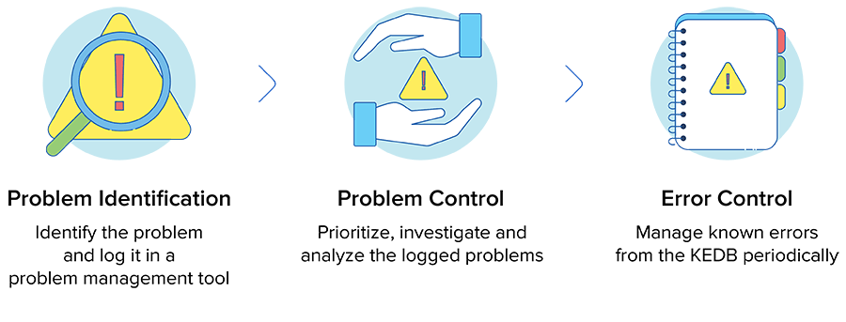Phases of Problem Management

Figure :Phases of problem Management

1. Problem Identification

A problem may be detected inside an incident report or an evaluation of an existing incident. when the reason for an occurrence or collection of incidents is uncertain, it's far most probably. with a purpose to prevent future carrier interruptions, proactive hassle detection may be very important.

Problem identification activities pick out and log troubles by way of;

* Appearing trend analysis of incident records.
* Detecting duplicate and routine issues.
* For the duration of major incident management, identifying a risk that an incident ought to recur.
* Analyzing information acquired from suppliers and partners.
* Analyzing records acquired from internal software program developers, test teams, and project teams.

1. Problem Control

when evaluating incidents, it is full-size to take into account that they will have interrelated reasons, which may additionally have complex relationships. Problem control includes,

* Prioritization
* Investigation
* Analysis
* Documenting known errors
* Workarounds

1. Error Control

This phase can control recognized errors. these acknowledged errors are often reconsidered to account for the impact they invent, and to test the efficiency of workarounds. it can perceive the capability permanent solution. whilst the solutions require change control, this has to be tested from the perception of fee, risk, and advantages

Principles of Problem Management

* Problem Identification

A problem may be detected within an incident file or an analysis of an existing incident. When the motive for a prevalence or collection of incidents is uncertain, it's far most probable. In an effort to prevent future service interruptions, proactive problem detection could be very critical.

* Problem Logging

It is important to document troubles for later reference. Details about the problem, inclusive of its kind, description, associated occasions, category, consumer records, repute, resolution, and closure, need to be recorded. To tag recognized problems and manage them in a database, these facts are crucial.

* Problem Investigation

An investigation into the foundation cause of a problem additionally relies upon the severity and urgency of the problem. Commonplace investigation strategies encompass reviewing the regarded Error Database (KEDB) on the way to discover similar problems. Then, the great direction of motion is decided to solve the problem.

* Resolution

As soon as resolved and the answer is determined, it is able to be implemented the usage of a standard exchange procedure. it's also important to make sure of service recovery. With the purpose to repair the problem permanently, a new change has to be raised. Alternate control handles the assessment, planning, and execution of changes.

* Evaluation

At some point at this level, it is critical to study the resolution of the problem, and its effect on the enterprise as well as perform a risk analysis. This guarantees that the problem control procedure is executed easily and always progressed for destiny. This overview is recorded as well as shared with relevant groups and people.

* 1. Problem Management Examples
     1. Problem Identification

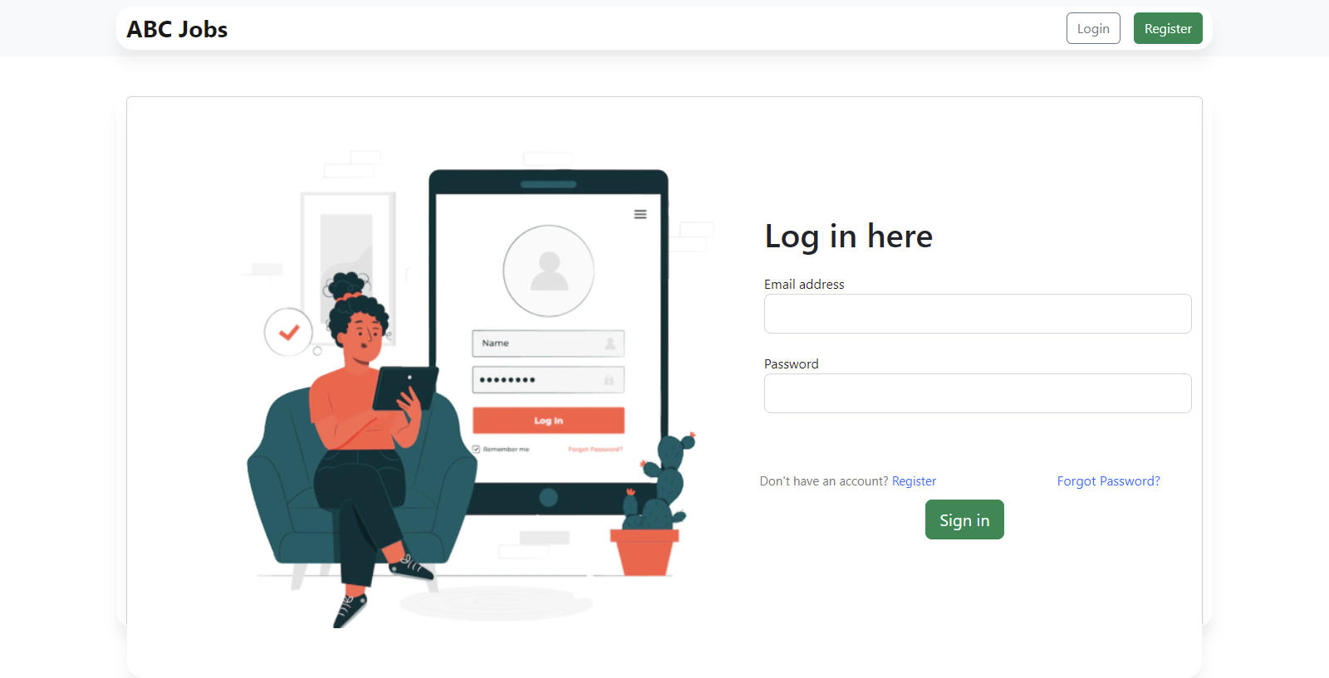When the user clicks on the forgot password link on login page, the user will be redirected to the index page instead of the forgo password page

Figure :Problem Identification - Screenshot of login

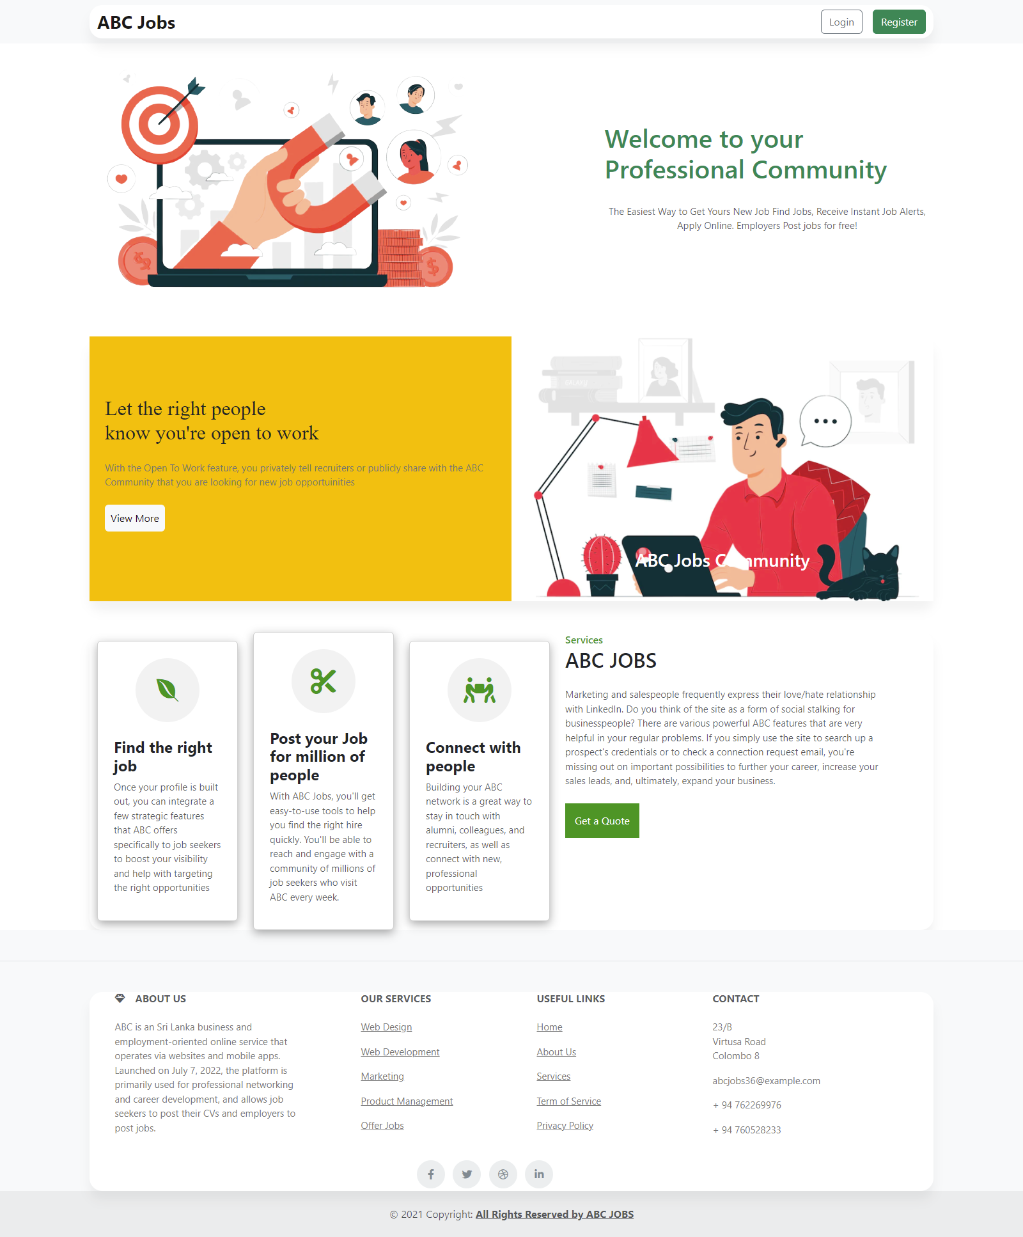

Figure :Problem Identification - Screenshot of Landing Page

|  |  |  |
| --- | --- | --- |
| No | Class | Problem |
| 01 | MainController.java | Wrong Mapping  **“**@RequestMapping("/forgotpassform")  **public** String index() {  **return** "index";  }” |

* + 1. Problem Logging
    2. Problem Investigation
    3. Resolution

Change the path in MainController.java as,

@RequestMapping("/forgotpassform")

**public** String forgotpassform() {

**return** "forgotpassform";

}

Task 2

1. Various tools, process & technologies to facilitate problem  
   identification, investigation, analysis & resolution

* Problem Identification

Techniques = Issue Tracking System

Tool = Excel Sheet

Using an Excel sheet to make a tracking document template is an important tool for problem identification.

Process:

* Receive a problem report
* Verify the problem
* Logging the problem issue
* Resolving the problem
* When it’s resolved, it will be remarked as resolved in the issue tracking system

|  |  |  |  |  |  |  |  |  |  |  |
| --- | --- | --- | --- | --- | --- | --- | --- | --- | --- | --- |
| **Issue Identification and Tracking Document** | | | | | | | | | | |
| **Created By:** | | | Chathushi | | Last Update By: Chathushi | | |  | | |
| **Date Created:** | | | 19 October 2022 | | Last Revision Date: October 2022 | | |  | | |
| **Issue No.** | Issue Description | Issue Type | Identified By | Date Identified | Issue Assigned To | Target Resolution Date | Priority | Status | Date Resolved | Resolution Description |
| **1** | Thank you, page is not showing, | Technical Issues | Software Tester Team | 19 October 2022 | Software Development  Team | 20 October 2022 | Low | Resolved | 19 October 2022 | Correcting the letters from code in MainController |
| **2** | When the user clicks on forgot password link on login page, the user will be redirected to the index page instead of forgot password page | Technical Issues | Software Tester Team | 19 October 2022 | Software Development  Team | 20 October 2022 | Medium | Resolved | 19 October 2022 | Correcting the code in MainController.java |
| **3** | User registration data is not stored in database | Technical Issues | Software Tester Team | 19 October 2022 | Software Development  Team | 22 October 2022 | High | Resolved | 21 October 2022 | Correcting the code in controller and dao class |

* Problem Investigation

Techniques = Root Cause Analysis

Tool = Fish Bone

Process:

* Define the problem statement
* Find the root cause
* Fix the root cause
* Finalize solution
* Problem Resolution

Techniques = Known Error Database

Tool = Excel Sheet

Using an Excel sheet to make a tracking document template is an important tool for problem identification.

Process:

* Adding known error records
* Create a known error record with the symptoms and resolution details
* Accessing known error records
* Search KEDB and apply fix
* Deleting known error records
* Permanent solution implemented

Task 3

1. Investigate & Diagnose problems.
   1. Investigate Problem

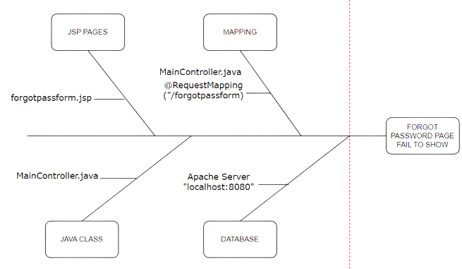We narrow the problem causes into the Controller and Security Configuration class

Figure :Investigation Problem

* 1. Diagnose the Problem

Identify the root of the problem by removing the error (Debugging)

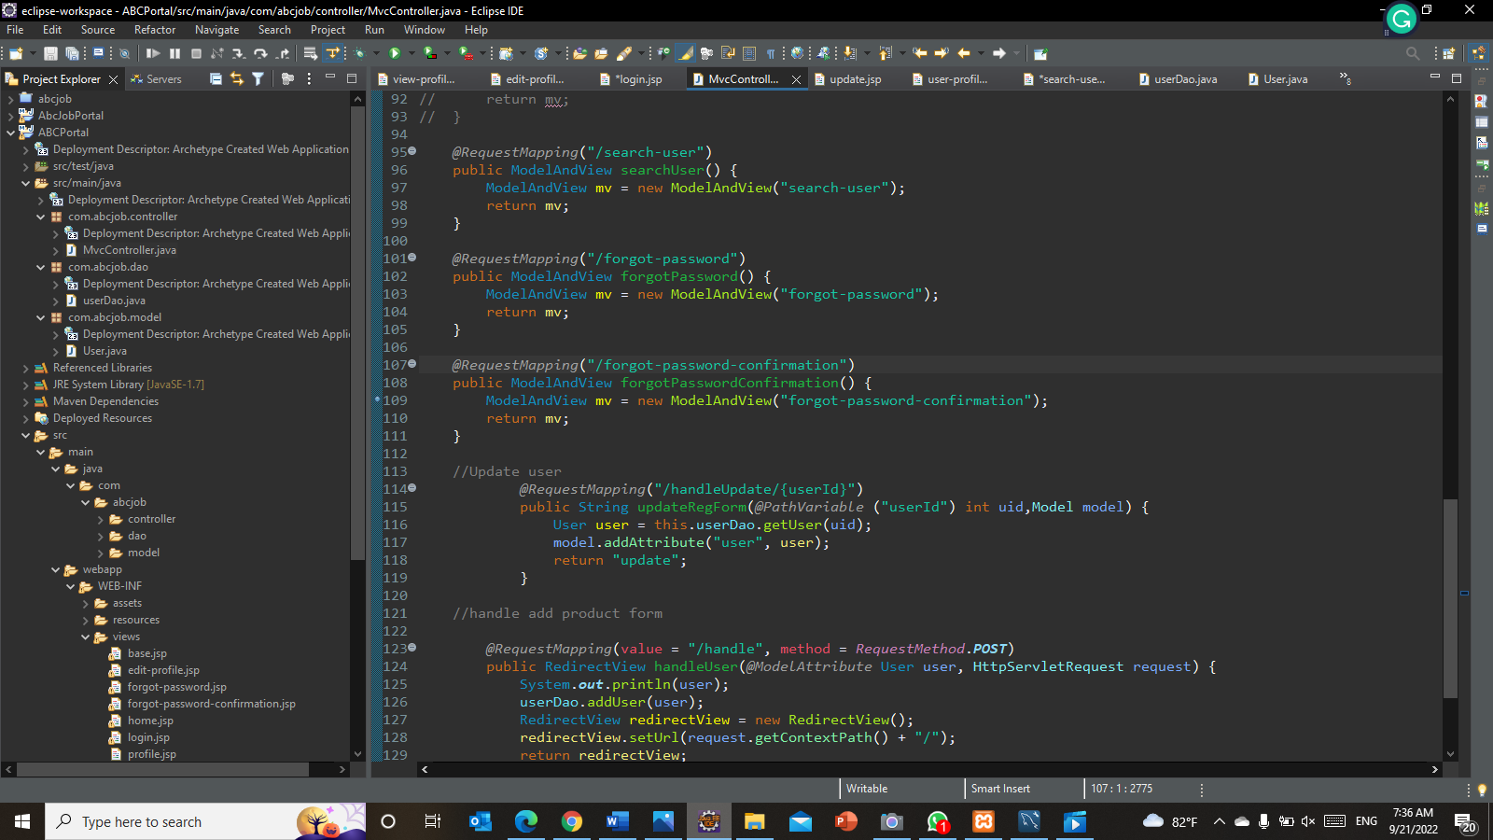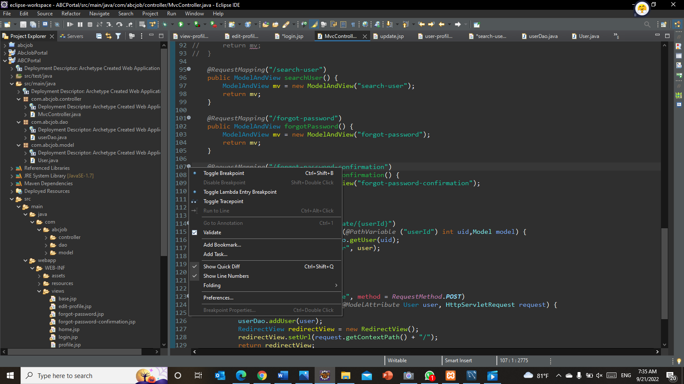**Step 1** – Set Breakpoints

Breakpoint: A blue circle should then appear next to the line:

Figure :Screenshot of debugging in eclipse step 1

**Step 2** – Start the program in Debug mode

(Right click on project🡪Debug as🡪Debug as server)

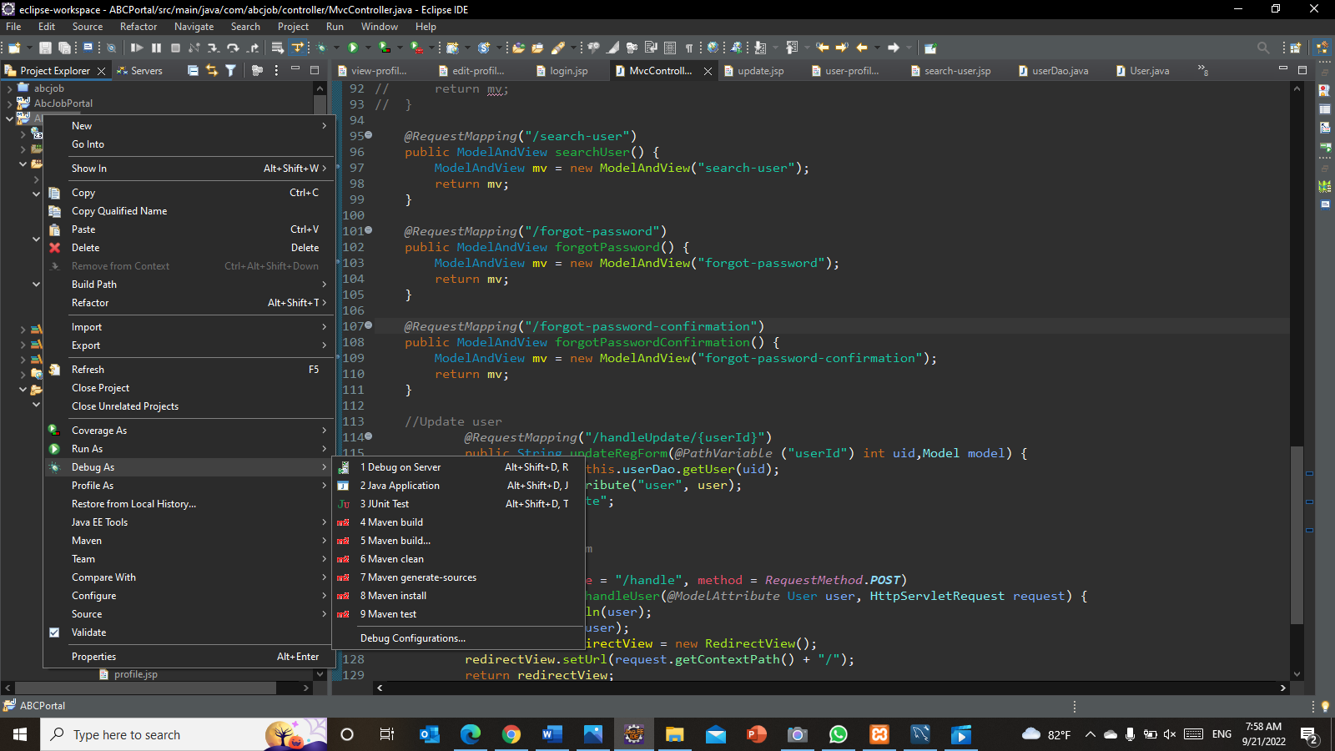

Figure :Screenshot of debugging in eclipse step 2

**Step 3** – Showing debugger details in the console

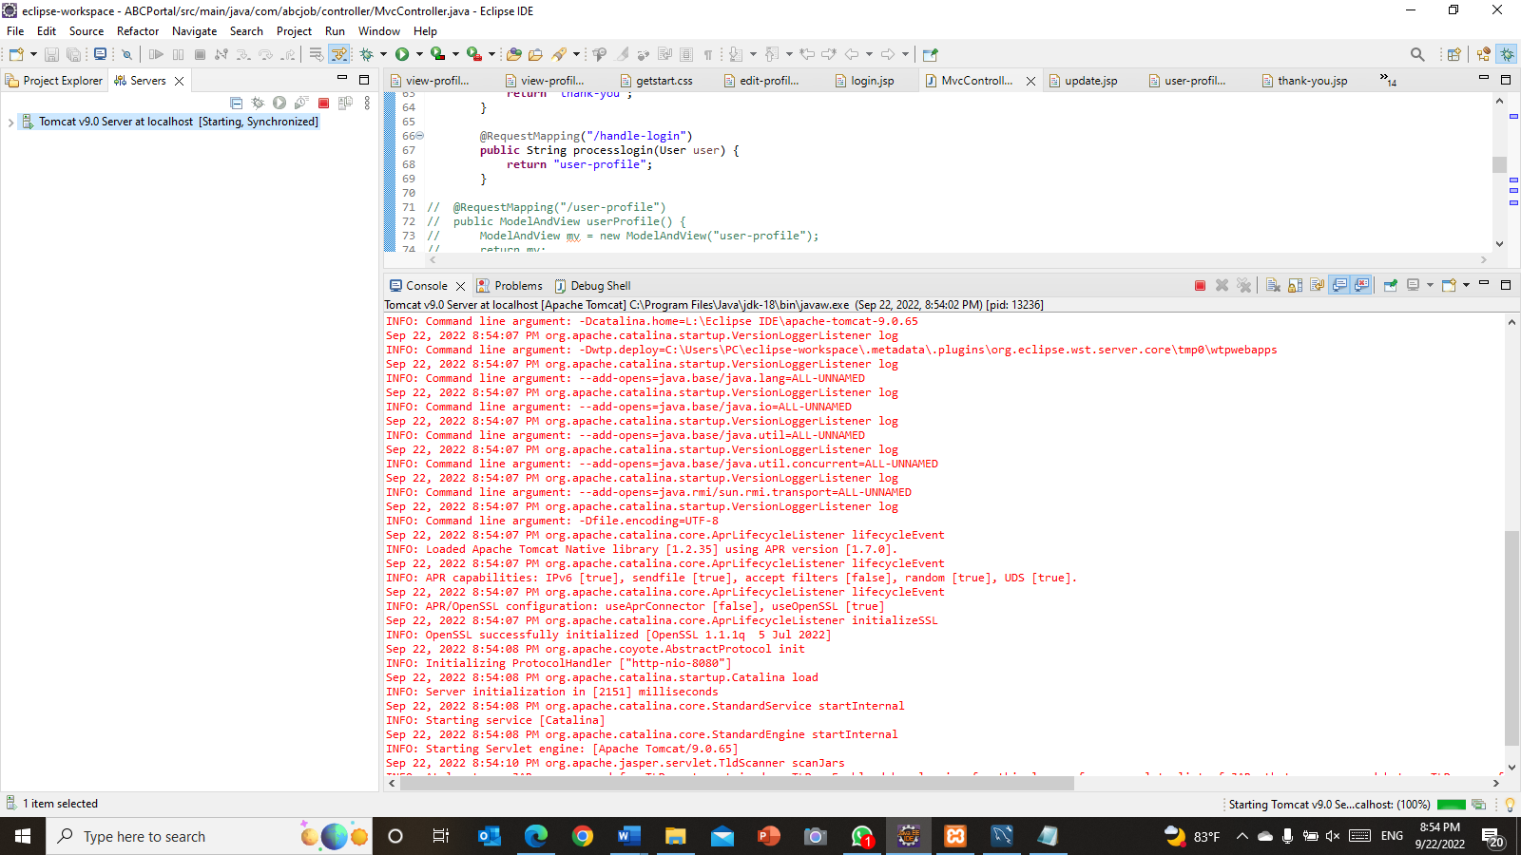

Figure :Screenshot of debugging in eclipse step 3

**Step 4** - Controlling the program execution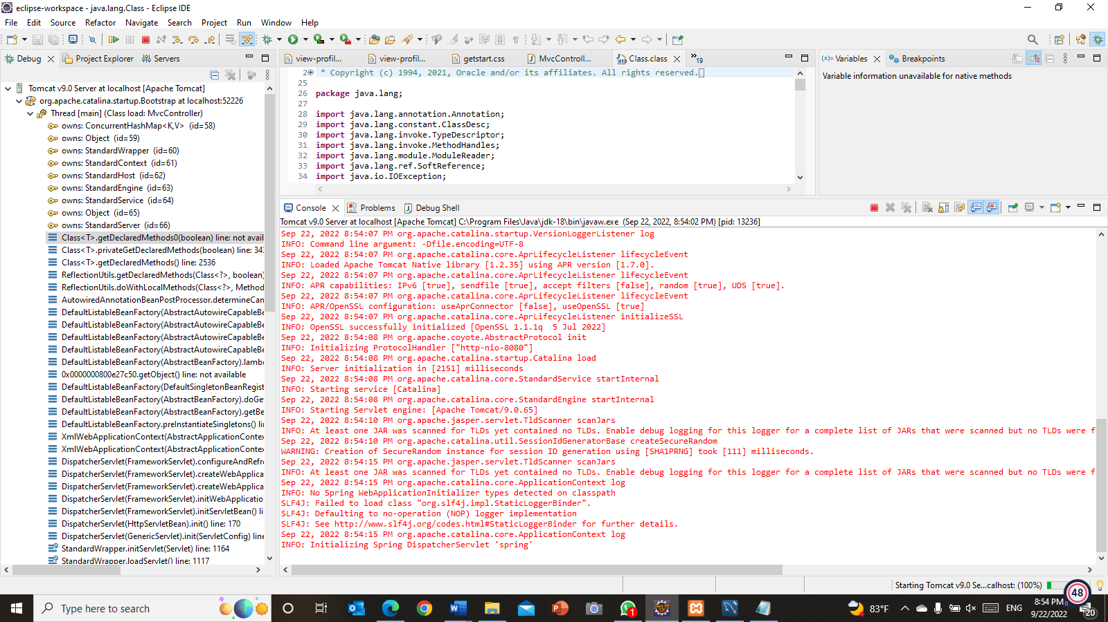The call stack indicates the parts of the program which can be currently executed and the way they relate to each other. The present-day stack is displayed inside the Debug view

Figure :Screenshot of debugging in eclipse step 4

Step 5 - Breakpoints view and deactivating breakpoints

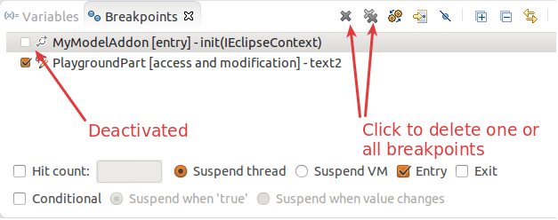

Figure :Screenshot of debugging in eclipse step 5

Step 6 -Evaluating variables in the debugger

The variables view shows fields and nearby variables from the contemporary executing stack.

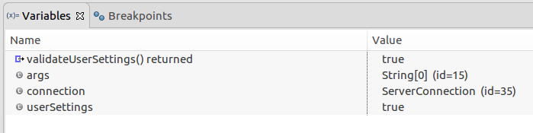

Figure :Screenshot of debugging in eclipse step 6

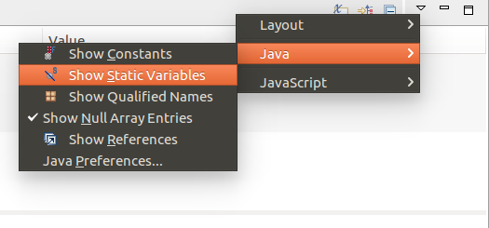Step 7 – Use the drop-down menu to display static variables

Figure :Screenshot of debugging in eclipse step 7

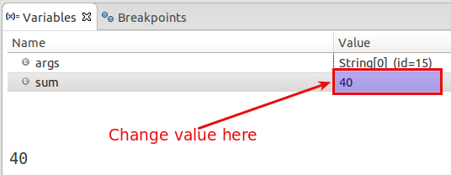Step 8 - Changing variable assignments in the debugger

Figure :Screenshot of debugging in eclipse step 8

Step 9 -Controlling the display of the variables with detail formatter

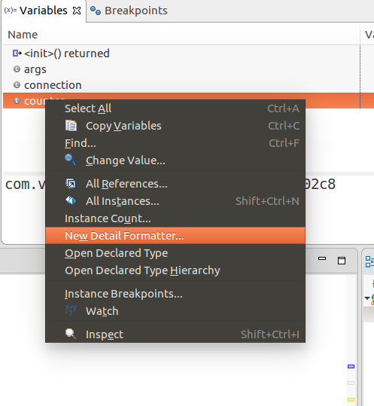

Figure :Screenshot of debugging in eclipse step 9

Task 4

1. Explain and Prioritize
   1. Prioritize and Categories problems:

**Tier 1: Low-priority issues**

Thank you, the page is not showing.

**Tier 2:** **Medium priority issues**

When the user clicks on forgot password link on the login page, the user will be redirected to the index page instead of forgot password page

**Tier 3:** **High-Priority Issues**

User registration data is not stored in a database

* 1. 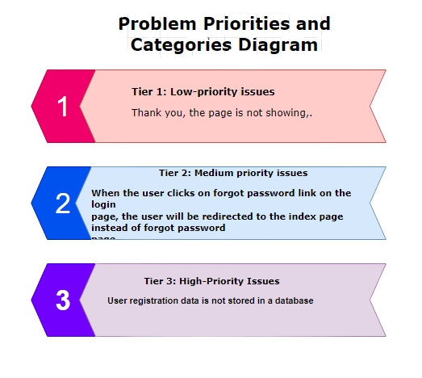Problems Categories Diagram

Figure :Problem Priorities and Categories Diagram

**Task 5**

1. Problem Management Solution

Solution for forgot password page display data failure

* Using the fishbone tool, we discover the root cause (root cause analysis)
* Test the code once more
* Add the problem to regarded error database
* Debug the code using breakpoints
* Thinking of the solution for the root cause
* Regulate the root cause problem
* After rerunning the application on debug mode
* If the problem is resolved, update the known error database

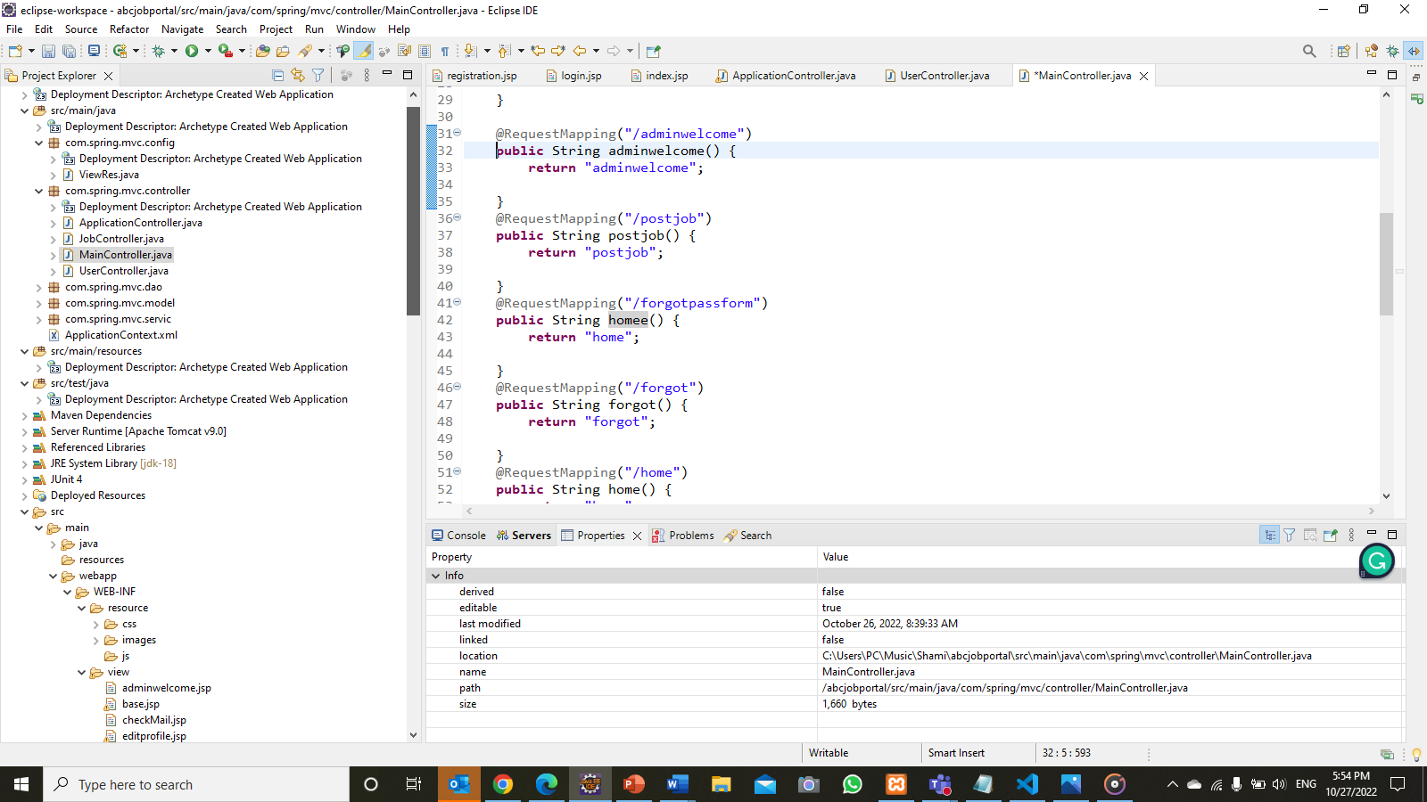

Figure :Screenshot of MainController.java before fixing the problem

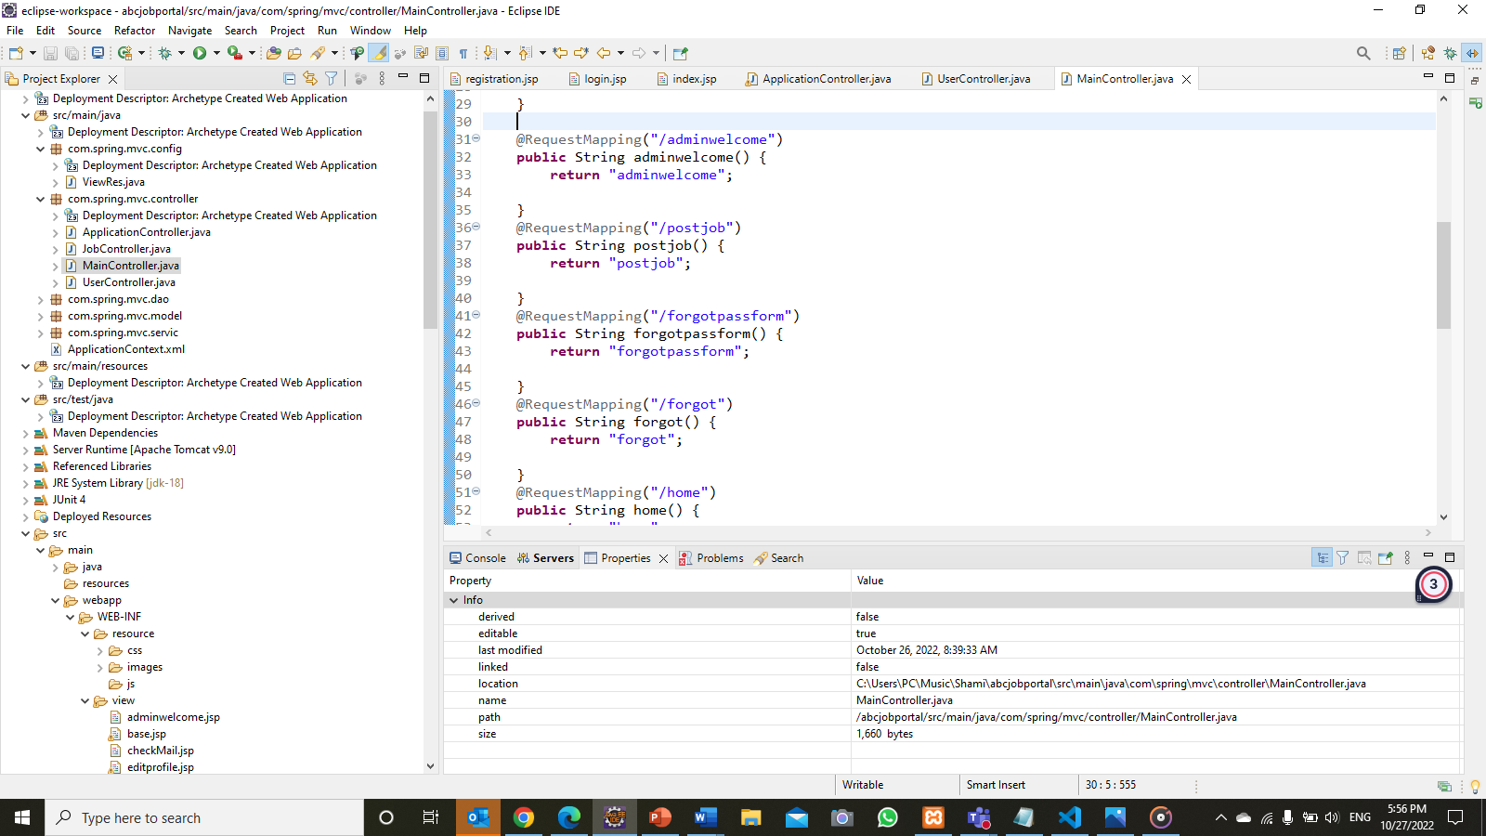

Figure :Screenshot of MainController.java after fixing the error

After modifying, then re-debug to check if the problem is solved

|  |  |  |  |  |  |  |
| --- | --- | --- | --- | --- | --- | --- |
| **Issue No.** | **Issue Description** | **Issue Type** | **Root Cause** | **Workaround** | **Status** | **Date Resolved** |
| **1** | Thank you, page is not showing, | Technical Issues | In getmapping method or uppercase lowercase mis correction | Correcting the letters from code in MainController.java | Resolved | 19 October 2022 |
| **2** | When the user clicks on forgot password link on login page, the user will be redirected to the index page instead of forgot password page | Technical Issues | Wrong mapping in MainController.java class | Correcting the code in MainController.java | Resolved | 19 October 2022 |
| **3** | User registration data is not stored in database | Technical Issues | Dao class is not mentioned in controller class correctly | Correcting the code in controller and Dao class | Resolved | 22 October 2022 |
| **4** | Attached files not showing in bulk mails | Technical Issues |  |  | Incomplete |  |

**Task 6**

1. Systems will be implemented

ABC community portal is a platform that offers job opportunities to people. Users cans register to this ABC Jobs community portal and log in. After they can search for users, search for jobs and apply for them and update their profile

* Registration

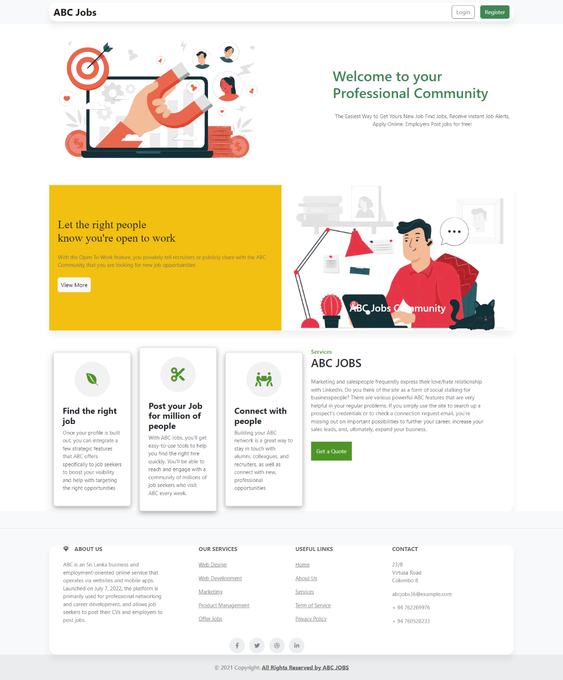In the registration function, users can register into the ABC community portal. That data is stored in the database and the password will be encoded

Figure :Registration Process - Screenshot of Home Page

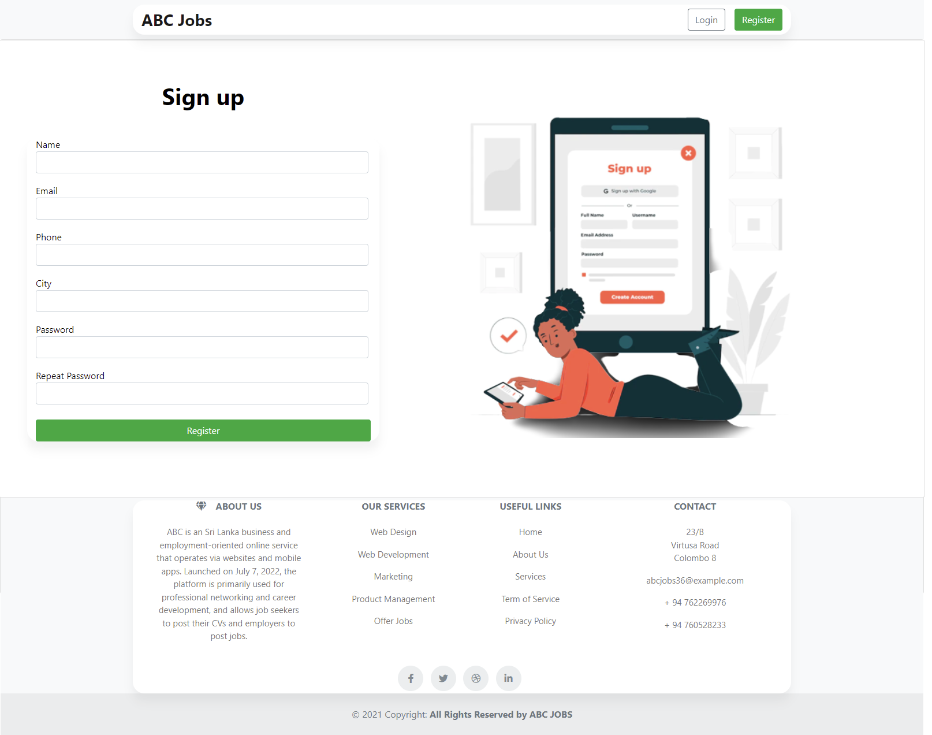

Figure :Registration Process-Screenshot of Registration Page

* Login

Login characteristic identity implemented and working perfectly. The roles of the user and admins are handled in the roles handler class. With the assistance of the spring security, login feature is working smoothly. So, users can log in effortlessly

* User Login

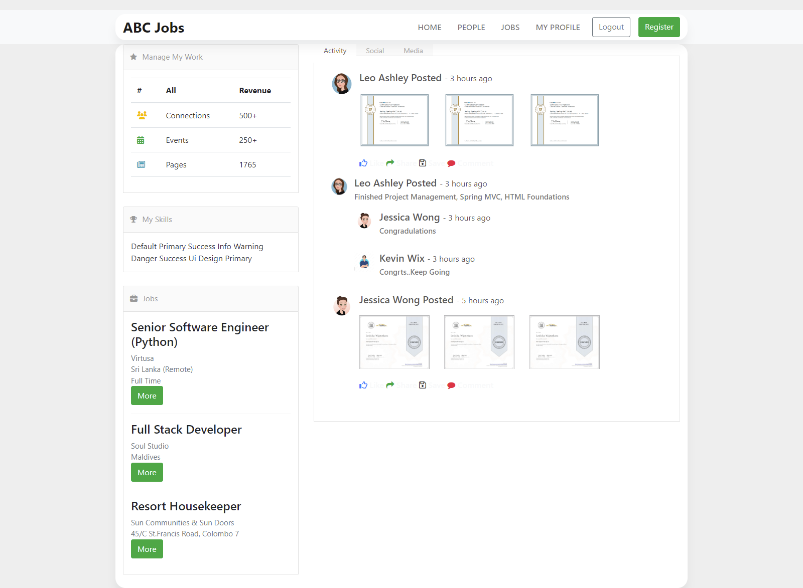 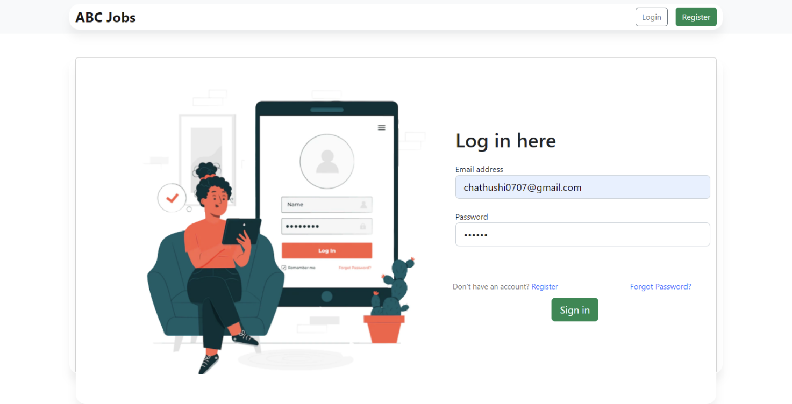

Figure :Login Process - Screenshot of User Home Page

Figure :Login Process-Screenshot of User Login

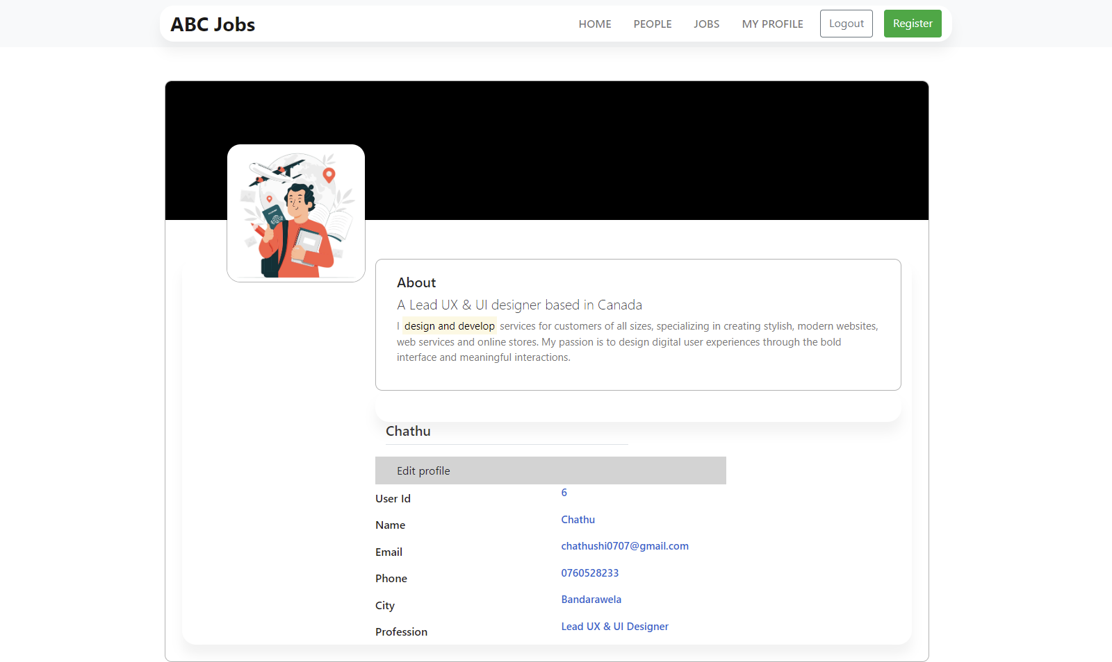

Figure :Login Process - Screenshot of User Profile Page

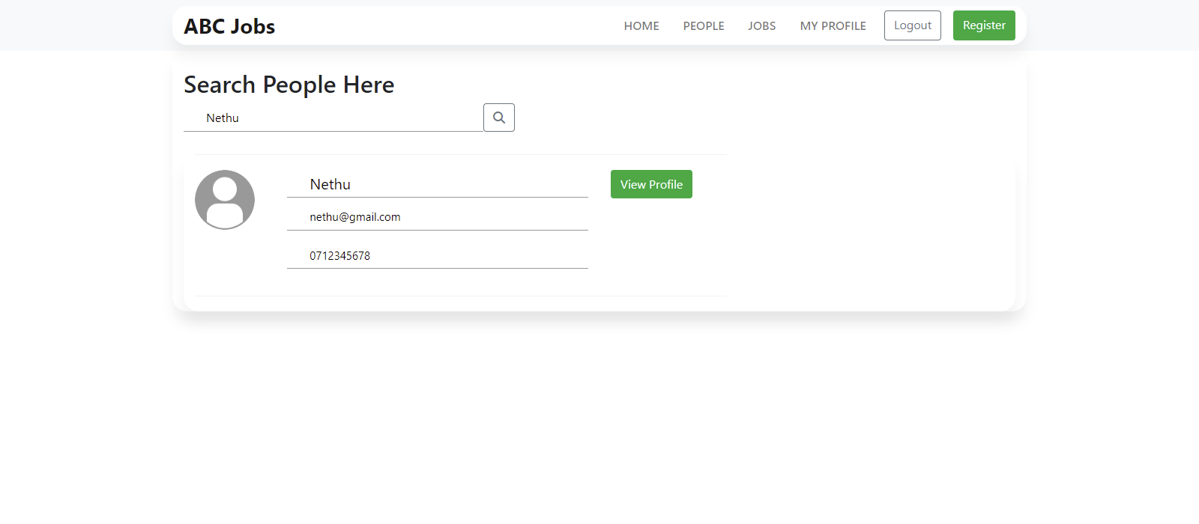User Search User Page

Figure :Search User - Screenshot of User Search User

* Update Profile

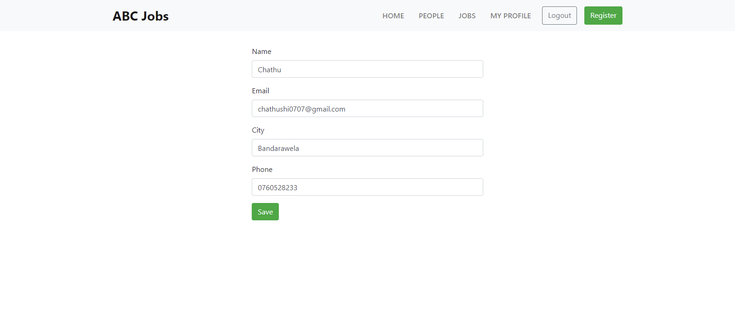Users can update their records using this update user function. After updating new data will updated on database

Figure :Update Profile - Screenshot of update profile page

Figure :Update Profile - Screenshot of User Profile page with Edit Function

* User – View Job

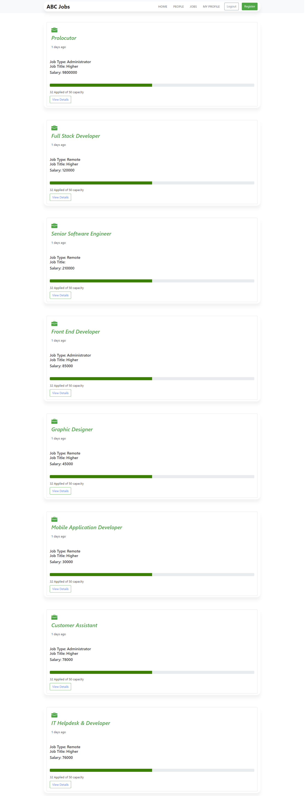User can view all jobs

Figure : Screenshot of User - View Jobs

* User – Apply Job

User can apply any job

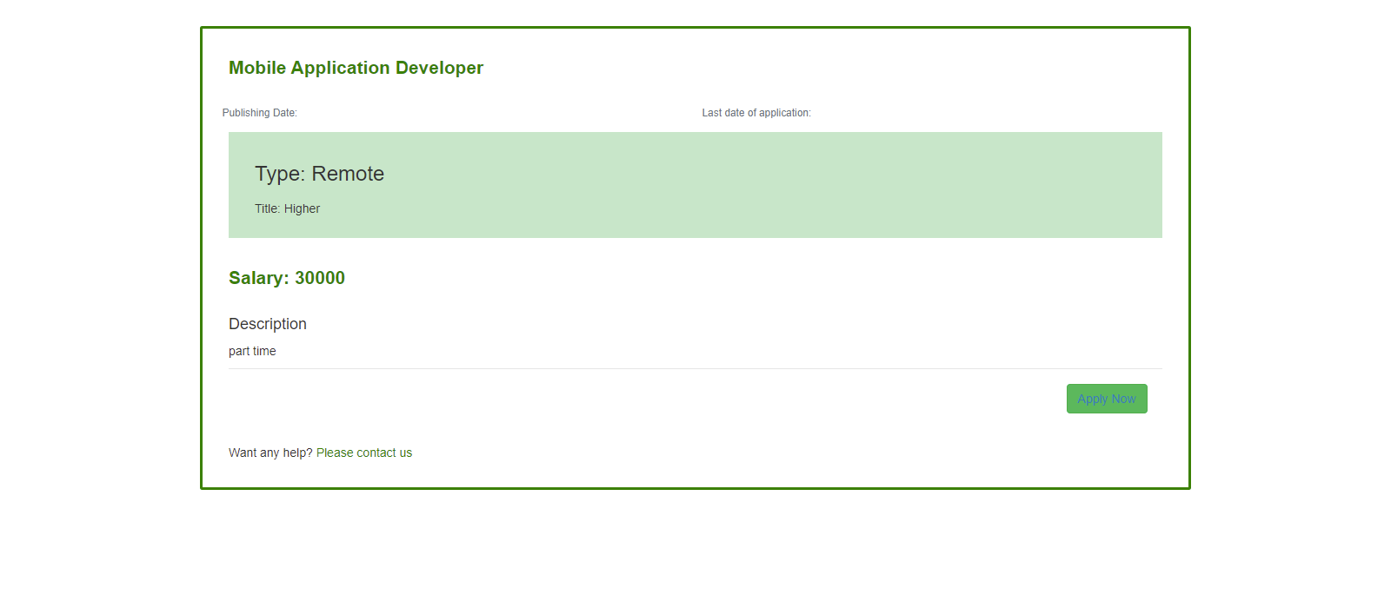

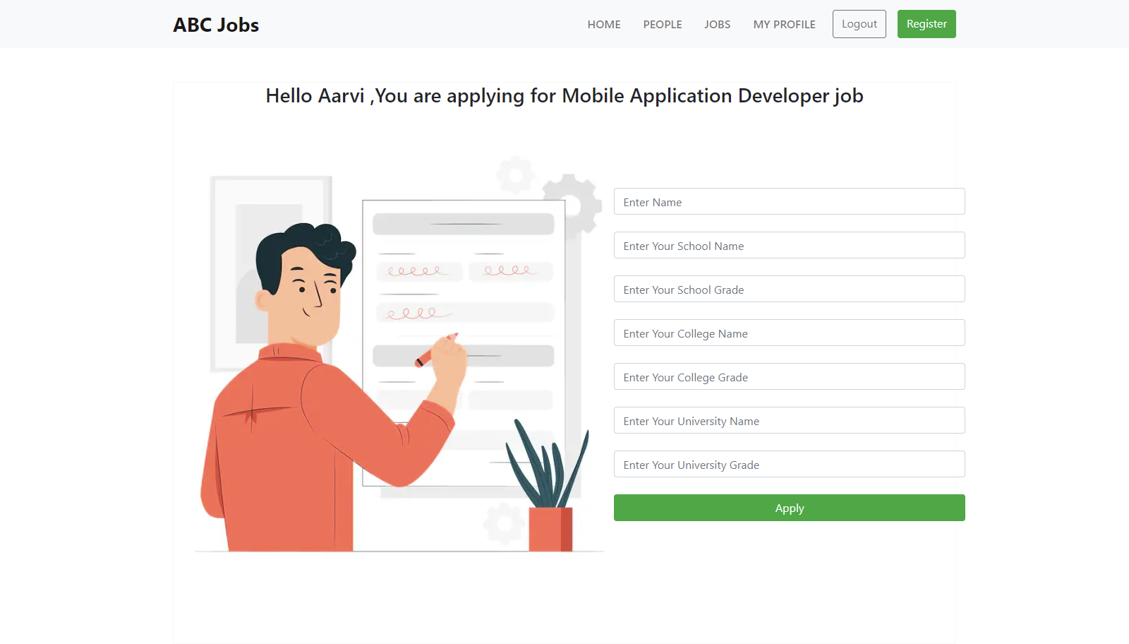

Figure : Screenshot of User - Apply Job

* Admin Login

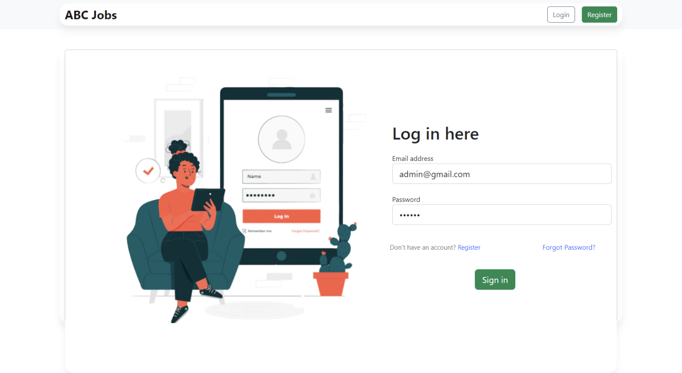

Figure :Login Process - Screenshot of Admin Login

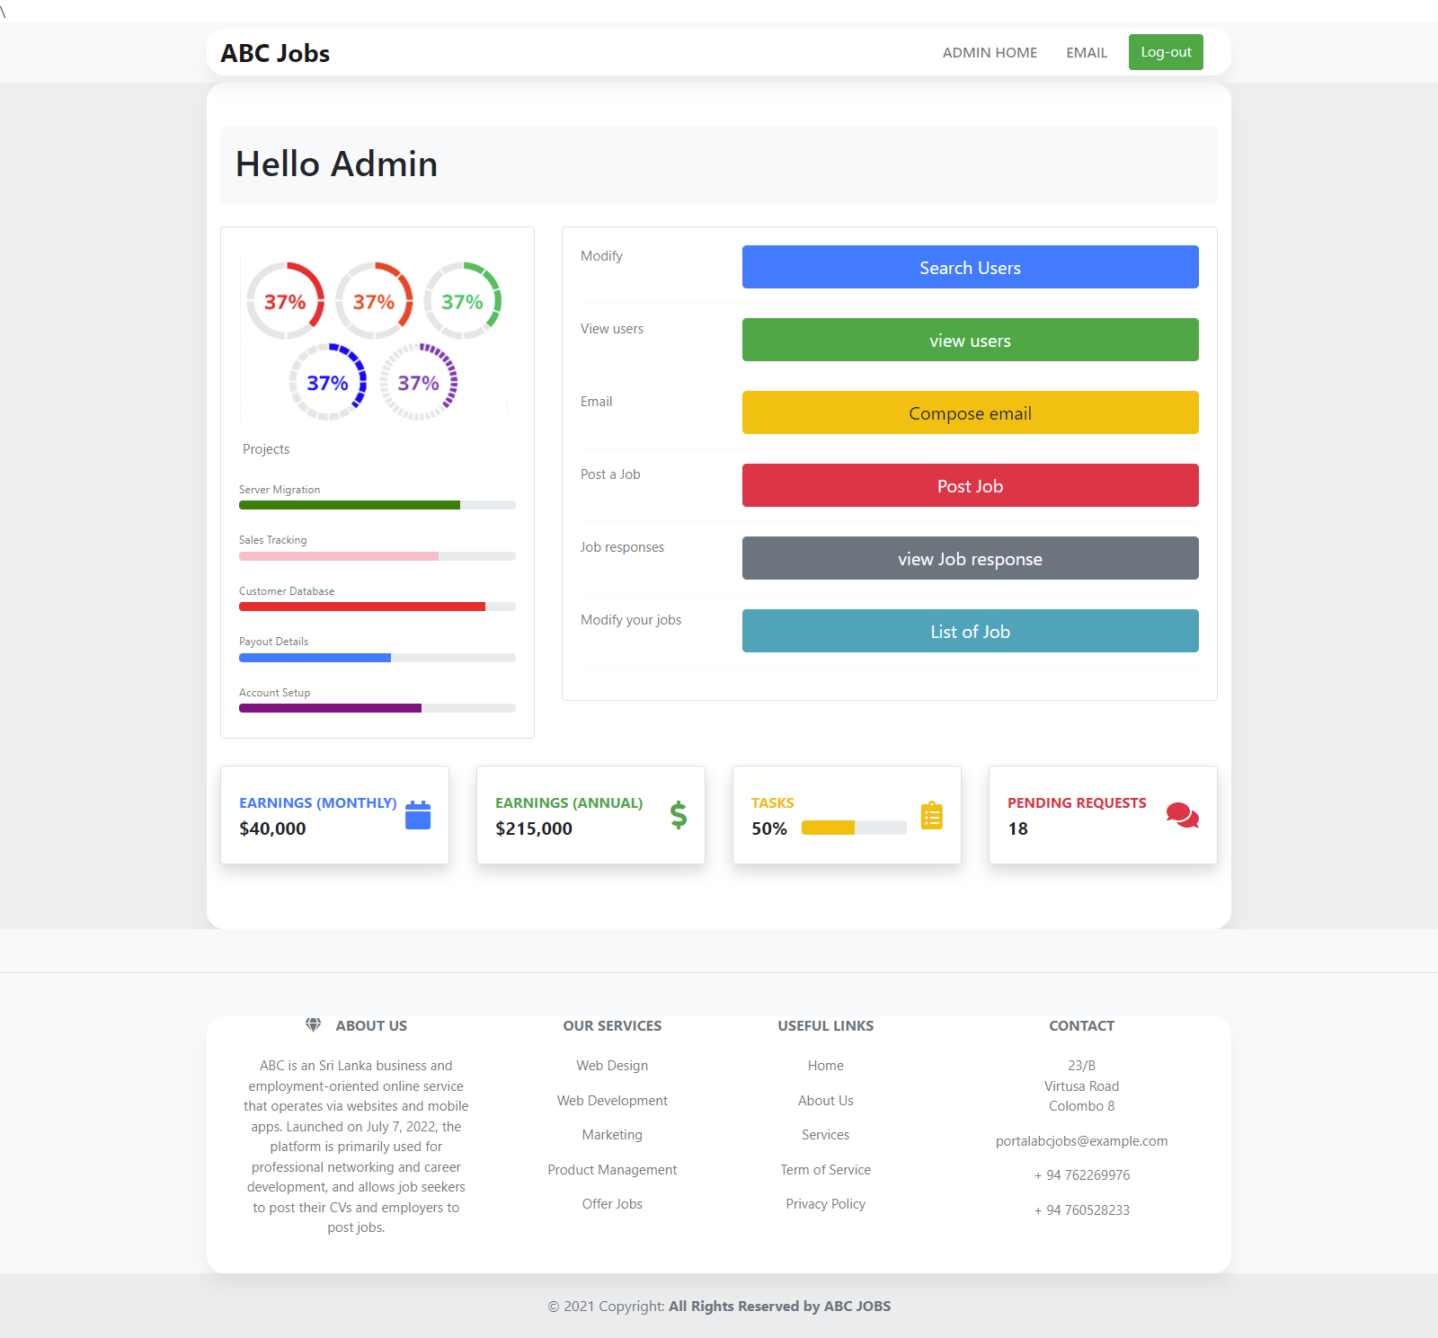

Figure :Login Process - Screenshot of Admin Profile Page

* Search User

Search user function is need to search other users in the ABC community Portal. Also, admin can search the users

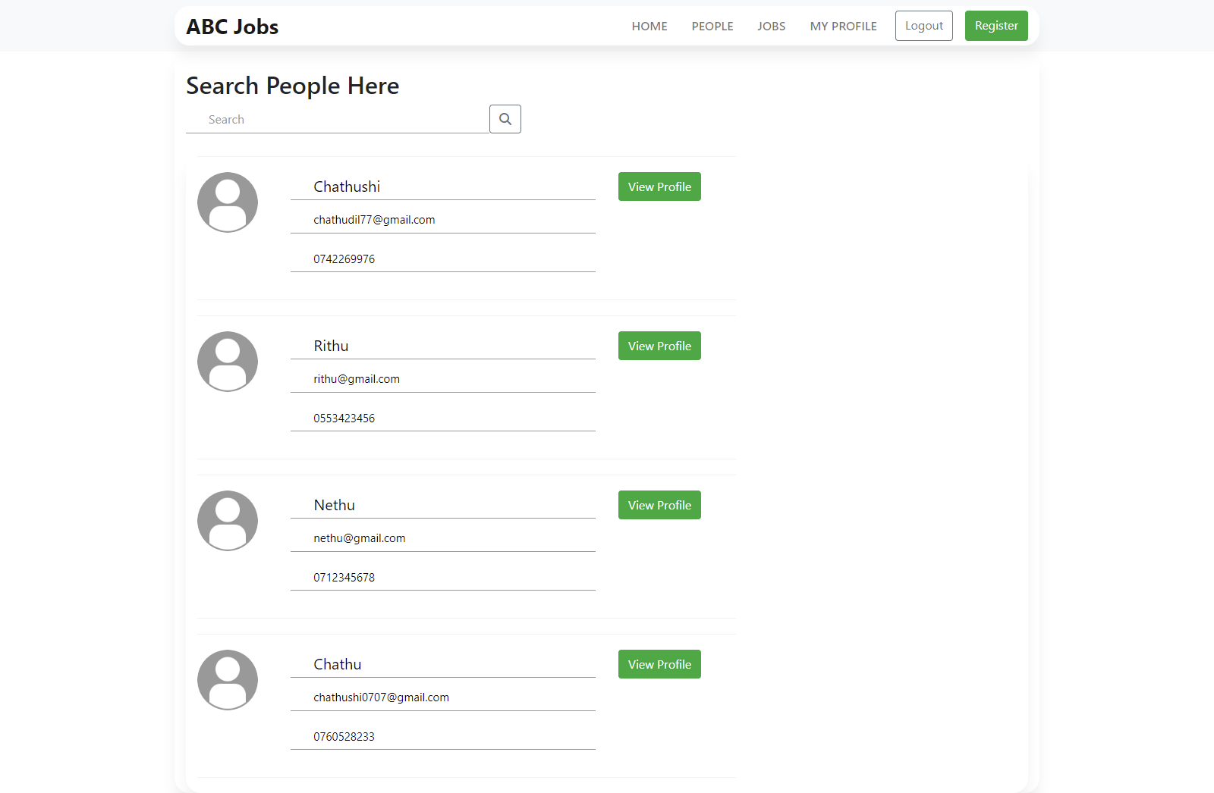Admin Search User Page

Figure :Search User - Screenshot of Admin Search User



* View Users

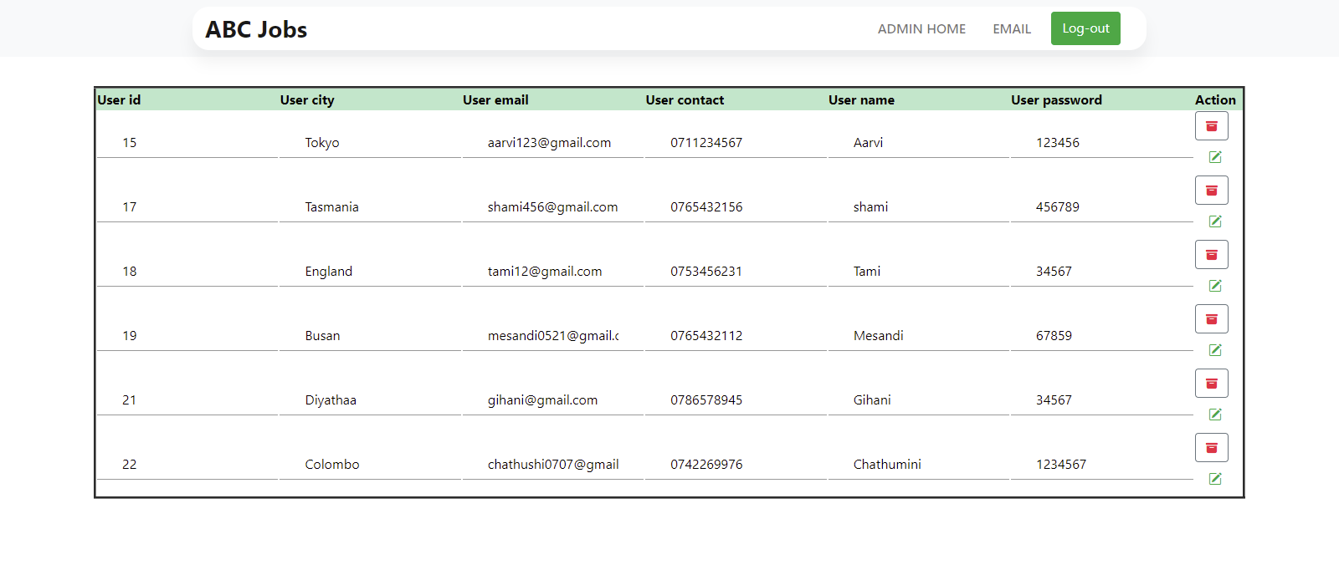Admin can view users, add users, delete and edit users

Figure :Screenshot of Admin - View Users



* Bulk Mail

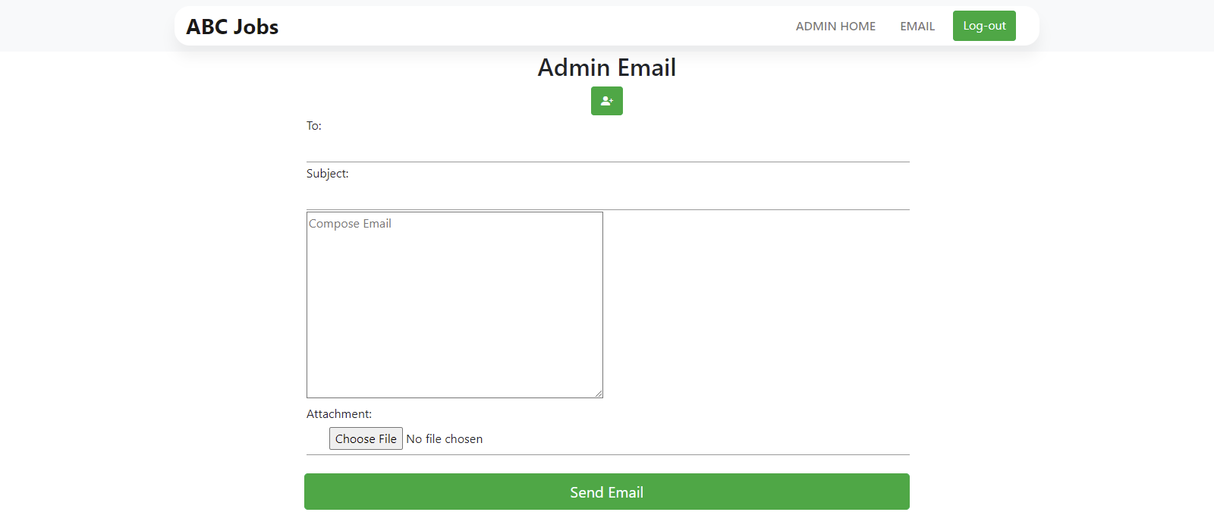Admins can send bulk mail to users

Figure :Screenshot of Bulk Mail Page

* Post Job

Admin can post job

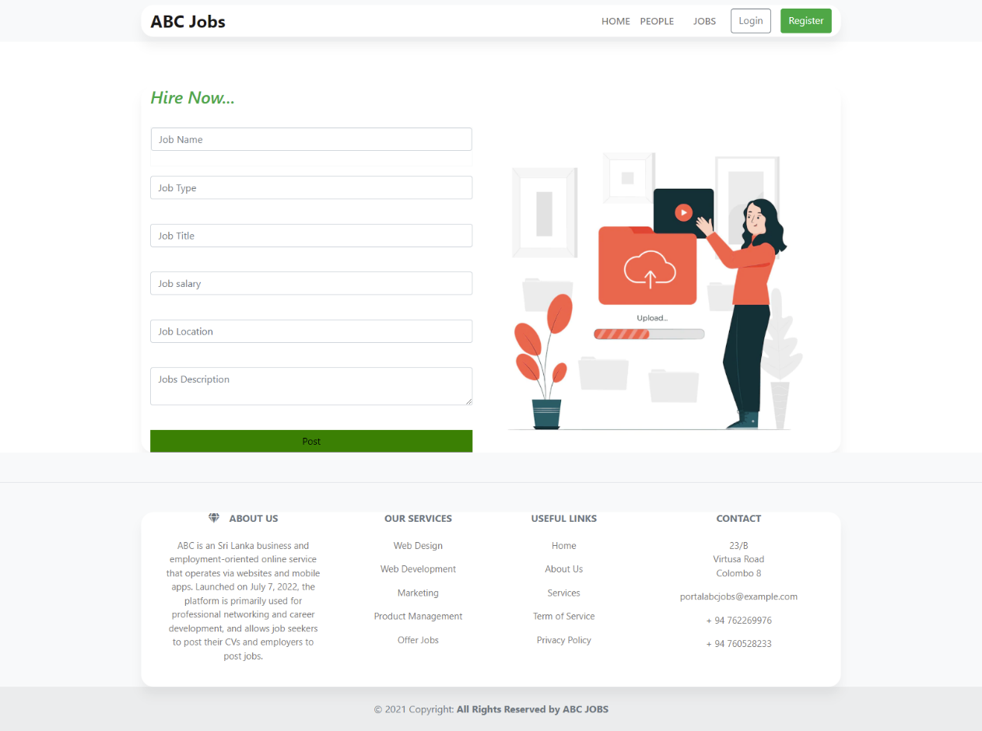

Figure :Screenshot of Post Job Page

* View Job Response

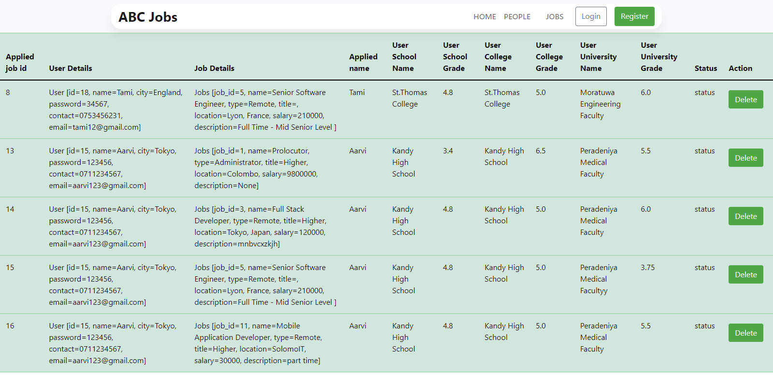

Figure :Screenshot of View job response

* Job List

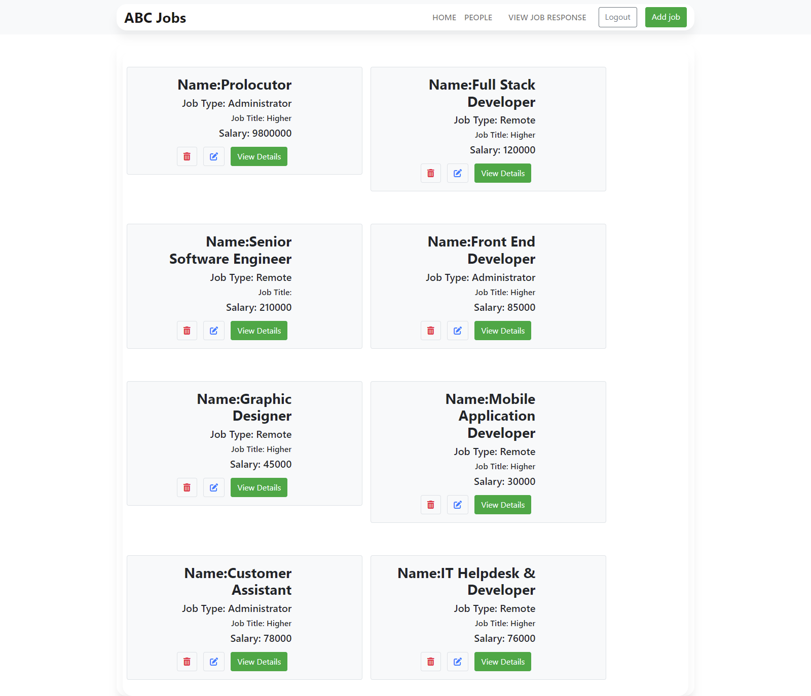

Figure :Screenshot of post job list

**Task 7**

1. Best Practices in Problem Management

* Solved issues should be kept in Known Error Database

You have a 'Known Mistake' when you have scrutinized your insightful abilities and distinguished the underlying driver of the issue. Known issues, similar to episodes, ought to be kept in a different region from the issue. Basically, it empowers you to be more unique in your classification. This permits you to recategorize a error to something more proper after an investigation

* Clients should be separate from the person handling the incident

Keeping everything in a hold-all is enticing. While managing a call, search for an area that can act as an all-in-one resource. Isolating issues from incidents and logging them in their own devoted space, then again, can assist with working on your cycles.

* Having a problem manager

Having somebody that is eventually responsible for Issue Management can vastly help to improve your overall process.

* Let your operators contribute: Share knowledge

Having a manager is perfect, but collaboration is key. Invite your group to take advantage of their insight and experience by permitting them to add to problem management. This can add a fascinating variety to their roles, and can assist you with recognizing the main driver all the more rapidly in the event that you have sharp partners who are great at distinguishing issues.